LOUIS HAYES: SERENADE FOR HORACE

BASS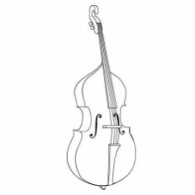 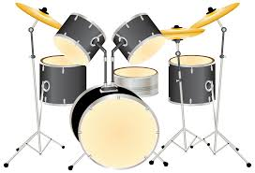
DRUMS

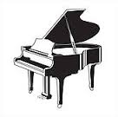
PIANO VIBES 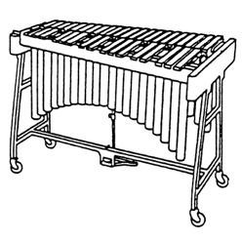 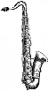 TENOR SAX

